Cal Poly Humboldt Sponsored Programs Foundation
Job Announcement
This is not a state position
Area Director, Small Business Development Center (SBDC)
Location: (8) Areas across Northern California
Status: Full-Time | 12 Months per Year (In-Office Position)
Salary: $95,000 – $155,000 DOE
Program: Northern California Small Business Development Center (NorCal SBDC)
Reports To: NorCal SBDC Lead Center
GENERAL INFORMATION
The Northern California Small Business Development Center (NorCal SBDC) is one of the nation's largest economic development networks, serving 36 counties and playing a pivotal role in the region's economic development ecosystem. Through coordinated efforts across Northern California, NorCal SBDC connects entrepreneurs with the resources and support they need to launch, grow, and strengthen their businesses.
As one of eight of the NorCal SBDC Areas, each Small Business Development Center (SBDC) serves a pivotal role in the region’s economic development ecosystem, supporting entrepreneurs and growing companies throughout each regional area. The center delivers high-impact 1:1 advising, access to capital, strategic resources, and targeted training programs to strengthen and serve our small business communities.
All SBDC Areas are part of the Northern California SBDC Network, hosted by Cal Poly Humboldt Sponsored Programs Foundation, and funded through the U.S. Small Business Administration (SBA), California Governor’s Office of Economic Development (GO-Biz), and other public and private sources.
Each SBDC Area will oversee all SBDC services conducted within one of eight multi-county areas. The eight service territory areas and a map are included below.

SBDC Area Territory | Counties
1 | REDWOOD COAST: Del Norte - Humboldt - Lake - Mendocino - Trinity
2 | NORTH STATE: Butte - Colusa - Glenn - Lassen - Modoc - Plumas - Shasta - Siskiyou - Tehama
3 | NORTH BAY: Marin - Napa - Solano - Sonoma
4 | SACRAMENTO: El Dorado - Nevada - Placer - Sacramento - Sierra - Sutter - Yolo - Yuba
5 | SAN FRANCISCO: San Francisco
6 | EAST BAY: Alameda - Contra Costa
7 | SILICON VALLEY: San Mateo - Santa Clara - Santa Cruz
8 | SAN JOAQUIN: Alpine - Amador - Calaveras - San Joaquin

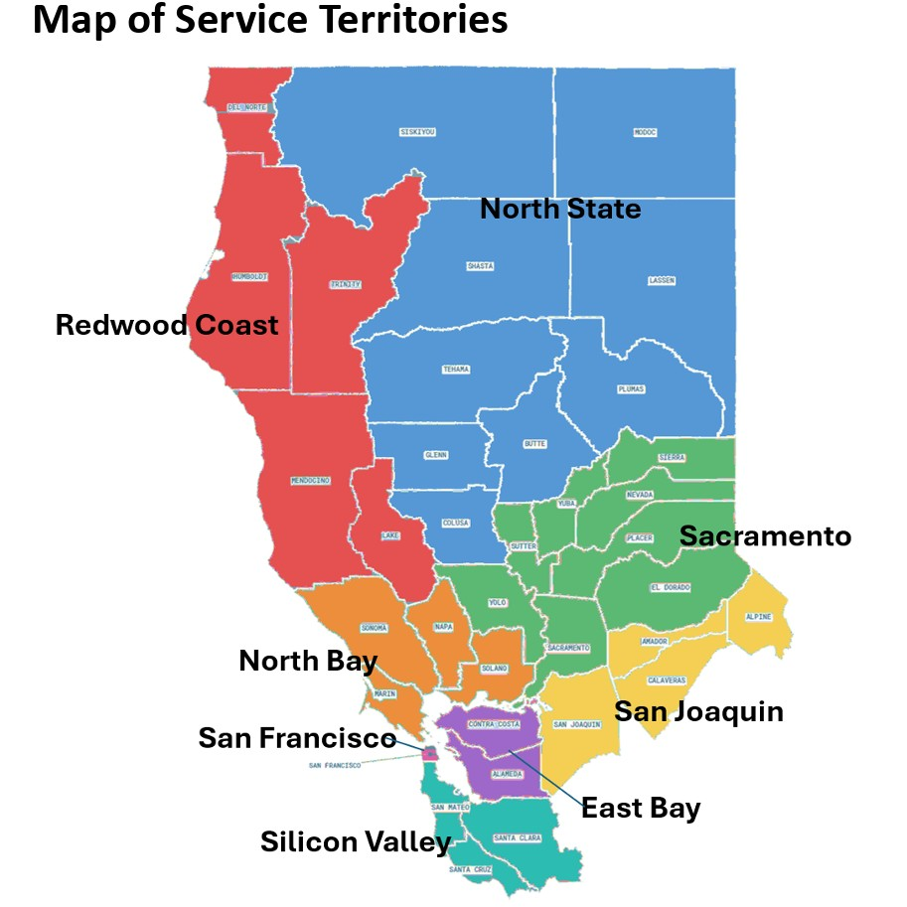
POSITION OVERVIEW
Each SBDC Area is seeking a dynamic, externally focused Area Director with strong business development, partnership cultivation, and relationship-driven leadership skills. The Area Director serves as the primary ambassador and growth driver for their respective Area of the NorCal SBDC territory—responsible for expanding visibility, strengthening partnerships, increasing client flow, and delivering measurable economic impact. This role is ideal for a leader who thrives in the community, builds trusted relationships and positions organizations as central regional resources. Please specify which Area(s) you are applying for in your cover letter.

KEY RESPONSIBILITIES
Business Development, Partnerships & Outreach
- Position the Area SBDC as a trusted, go-to resource for entrepreneurs, funders, and regional stakeholders
- Lead and execute strategic outreach and relationship-building efforts to maintain and expand the area’s presence and referral pipeline of small businesses
- Cultivate and maintain strong partnerships with lenders, local governments, chambers of commerce, economic development agencies, nonprofit organizations, educational institutions, and community-based partners
- Actively generate and manage partner channels that drive consistent client engagement and capital access outcomes
- Represent the Area SBDC at community events, conferences, stakeholder meetings, and public forums
- Collaborate closely with NorCal SBDC leadership and peer SBDC areas on regional and statewide initiatives
Strategy, Programs & Client Services
- Ensure SBDC services remain responsive, innovative, and aligned with regional economic priorities
- Plan, oversee, and evaluate delivery of advising, training, and referral services across designated area counties
- Develop and implement client acquisition strategies that expand reach into diverse and emerging entrepreneurial communities
- Personally provide one-on-one advising to clients, including startups and growing firms, with emphasis on capital readiness, growth strategy, and sustainability
- Adopt and advance outcomes related to client access to capital, job creation, and business growth
- Conduct joint monthly or biweekly meetings with host leadership to strengthen coordination, align program priorities and shared objectives, and identify new collaboration and partnership opportunities.
- Conduct joint monthly meetings with Neighborhood Branch leadership to align priorities, oversee office hours, events/trainings, and ensure high-quality, impactful service delivery.
Operations & Performance
- Lead center operations to meet or exceed annual performance and business impact goals
- Manage budgets, contracts, and resource allocation
- Supervise, train, and evaluate staff and contracted advisors; foster a high-performance, results-oriented team culture
- Develop and manage the center’s annual work plan in alignment with NorCal SBDC strategic priorities
- Ensure compliance with SBA, GO-Biz, and grant requirements, including accurate reporting and data tracking
System & Regional Coordination
- Coordinate closely with NorCal SBDC regional headquarters and Cal Poly Humboldt Sponsored Programs Foundation
- Participate in regional planning, meetings, and leadership activities
- Represent Area regional interests within the broader SBDC network
- Maintain a comprehensive tracking system to monitor targeted engagement with municipalities, chambers, lenders, legislative offices, and corporate partners, including outreach progress, partnership development, and measurable outcomes.

KNOWLEDGE, SKILLS & ATTRIBUTES
The ideal candidate brings:
- Strong understanding of entrepreneurial ecosystems, capital access, and regional economic development
- Proven experience in business development, partnership building, or external-facing leadership roles
- Demonstrated ability to build trust and credibility with senior-level executives, lenders, and public-sector leaders
- Experience delivering or overseeing advisory services, consulting, or client-based programs
- Excellent public speaking, communication, and relationship-management skills
- Strong operational, project management, and performance-management capabilities
- Budget management experience and comfort working in grant-funded environments
- Experience with or interest in institutional fundraising and sponsorship development
- Proficiency with common productivity tools and client management systems
PREFERRED QUALIFICATIONS
Preference will be given to candidates who demonstrate the following:
- A Master’s degree in business, economics, education, communications, or a closely related field; or an equivalent combination of education and experience.
- Prior experience working for a Small Business Development Center.
- Prior direct business consulting, training or teaching experience.
- Prior experience working within the business community, economic development programs, and/or small business ownership.
MINIMUM QUALIFICATIONS
- A Bachelor’s degree in business, economics, education, communications, or a closely related field; or an equivalent combination of education and experience.
- At least five years of management-level experience.
- Must be able and willing to travel overnight multiple times per year.

APPLICATION PROCESS
Qualified applicants should submit the following items via email to careers@norcalsbdc.org
- Cover letter (include which Area(s) you are applying for)
- Résumé
- Three professional reference contacts
- Cal Poly Humboldt SPF Employee Information Form for Applicants

Position will remain open until filled. Apply before September 14th, 2026 5pm to be included in the first round of application reviews.

ADDITIONAL INFORMATION
This position requires regular travel throughout Northern California and includes occasional evening and weekend commitments. A competitive benefits package is offered, including retirement, health, dental, and vision coverage.
While long-term continuation is anticipated, all NorCal SBDC positions are contingent upon continued state and federal funding. This is not a state or federal position.
Cal Poly Humboldt Sponsored Programs Foundation is an Equal Opportunity Employer. All qualified applicants will receive consideration for employment without regard to race, color, religion, age, sex including sexual orientation and gender identity, national origin, disability, protected Veteran Status, or any other legally protected status. More information about Cal Poly Humboldt SPF’s Equal Employment Opportunity hiring can be found here.
SPF adheres to the policy of employment at will, which permits the employer or the employee to end the employment relationship at any time, for any reason, with or without cause or notice as permissible by law. No SPF representative other than the Executive Director may modify at-will status and/or provide any special arrangement concerning terms or conditions of employment in an individual case or generally and any such modification must be signed in writing.
Maintaining eligibility to work in the United States is a condition of employment. Cal Poly Humboldt Sponsored Programs Foundation does not sponsor visas for staff, management, or temporary positions.
For assistance with the application process, please submit an Accommodation Request Form, which can be found here or contact ADA Coordinator at 707.826.3626 or confidential fax at 707.826.3625. For more information regarding accommodation, you may also visit the Cal Poly Humboldt Human Resources website at https://disability.humboldt.edu/. Individuals in need of a telecommunications relay service may contact the California Relay Service at 877.735.2929 TTY.
A background check (including a criminal records check) must be completed satisfactorily before any candidate can be offered this position within Cal Poly Humboldt SPF. Failure to satisfactorily complete the background check may affect the application status of applicants or continued employment of current Humboldt SPF employees who apply for this position. Background checks will be conducted only after a conditional offer of employment and in compliance with California Fair Chance laws.

